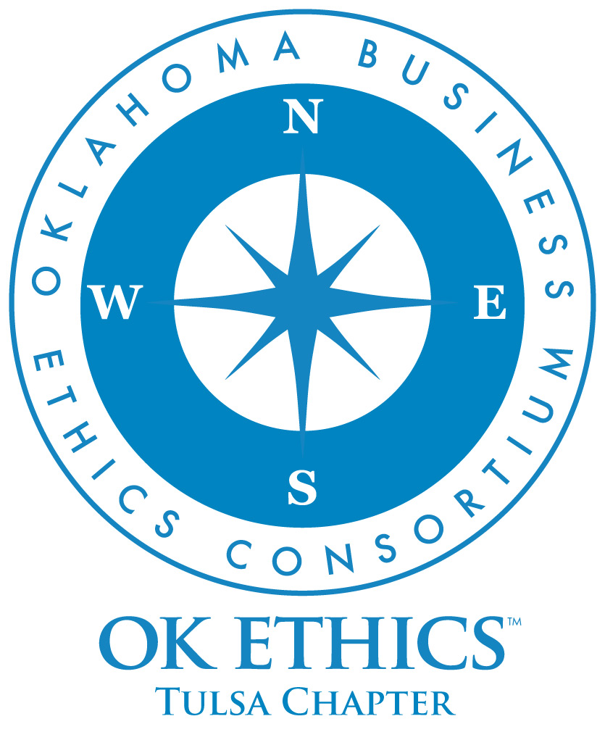
OKLAHOMA BUSINESS
ETHICS CONSORTIUM
Tulsa Chapter Meeting
November 20, 2008

We are pleased to welcome
PRSA as co-presenters

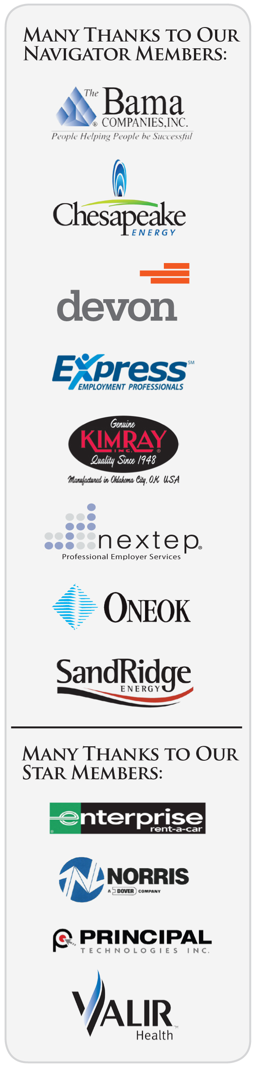
Meeting Agenda

I. Welcome (11:40) Nick Minden, OKEthics
Mary Waller, PRSA

Special thanks to certain individuals for making this meeting possible:
OKEthics - Carol Swarthout, Tom Clatfelter, Jenny Lizama, Deborah Gavula
PRSA - Andrea Myers, Tim Collwell, Nicole Morgan, Amber Remke

Additional thanks to Kelli Schneider of Full Force Marketing & Brand Development for our OK Ethics commemorative magazine – available on our website at www.okethics.org or at the registration table.

II. Chapter Announcements (11:45) Whitney Matthews, OKEthics

III. Guiding Principle (11:50) Lynn Flinn, OKEthics

IV. Introduction of Panel (11:55) Andrea Myers, PRSA

V. Panel Discussion (12:00)

"Crisis Communication: The Ethics of Conflicting Voices"

Panelists:
Jeff Hassell, partner with Gable & Gotwals
Joe Worley, executive editor for the Tulsa World
Barrett Waller, APR, president of Waller & Company
Darrean Browning, assignment manager from NewsChannel 8

VI. Q&A (12:45)

VII. Closing remarks (1:00) Nick Minden, OKEthics
Mary Waller, PRSA

OK ETHICS – Upcoming Events

Tulsa Chapter
- December 11 Steve Burrage, State Auditor
Joint meeting with OK Society of CPAs, FEI and the Institute of Internal Auditors

OKC Chapter
- December 10 Hospital Leaders Panel. “Prognosis, Methods & Treatment of Ethical Dilemmas”
- March 11 Clifton Taulbert. "Inside Community."

To register for a Tulsa event, or see a list of Oklahoma City or Norman chapter meetings, go to our Web site at www.okethics.org or call 918-808-1086
NOTE: Members of the Oklahoma Business Ethics Consortium frequently share information concerning various issues and developments that may have legal implications. The discussions, commentary, and handouts at Consortium meetings or presentations to other organizations are for general informational purposes only. They cover only some aspects of the subject topic, and do not constitute a complete legal analysis of the topic or how it might apply to any particular set of facts. Before taking any action based on information presented by a Consortium member, participants are encouraged to consult a qualified attorney. The observations and comments of presenters at Consortium meetings and networking are the views and opinions of the presenter and do not constitute the opinion or policies of the Consortium or any of its members. Please note that speakers are advised in advance of OkEthics policy against politicking, preaching, self-promotion and profanity.

OK ETHICS - Membership

Join today – You can make a difference!

Corporate Levels
NAVIGATOR $7,500 Includes 16 memberships; prepaid for all
OkEthics events – including Compass Awards
STAR $5,000 Includes 8 memberships; prepaid for all OkEthics
events – including annual Compass Awards
HORIZON $3,000 Includes 8 prepaid meals at all Tulsa events
LEADING $1,250 Includes 2 prepaid meals at all Tulsa events
FRONTIER $350 Includes 8 memberships; 8 members may attend
events at the discounted member rate

Individual Levels
TRAILBLAZER $500 Includes 1 prepaid meal at all Tulsa events
SCOUT $75 No prepaid meals; may attend events at
the discounted member rate

For more information on membership, go to www.okethics.org

PLEASE HELP US CONTROL COSTS BY LEAVING YOUR NAME TAG HERE!

